**PROJECT REPORT**

**ON**

***“NewsGuardian- Fake News Detection”***

Submitted in partial fulfillment of the

Requirement for the award of the degree of

**Bachelor of Computer Application**

** **

**Submitted To: Submitted By:**

Ms. Megha Bansal Pranav Chamoli

Asst Professor (10117702020)

VSIT

(Batch: 2020-2023)

**Vivekananda Institute of Professional Studies – Technical Campus**

**(Affiliated to Guru Gobind Singh Indraprastha University)**

**CERTIFICATE**

This is to certify that I, Pranav Chamoli of BCA 6th Semester from Vivekananda Institute of Professional Studies, Delhi has presented this project work entitled “NewsGuardian-Fake news detection” in partial fulfillment of the requirements for the award of the degree of Bachelor of Computer Applications under our supervision and guidance.

Ms. Megha Bansal Assistant Professor

**ACKNOWLEDGEMENT**

It is our proud privilege to express our profound gratitude to the entire management of Vivekananda Institute of Professional Studies and teachers of the institute for providing us with the opportunity to avail the excellent facilities and infrastructure. The knowledge and values inculcated have proved to be of immense help at the very start of my career. Special thanks to Hon’ble Founder, Vivekananda Institute of Professional Studies, Delhi for having provided us an excellent infrastructure at VSIT.

I am grateful to Prof. (Dr.) Supriya Madan (Dean, VSIT), and Ms. Megha Bansal for their astute guidance, constant encouragement, and sincere support for this project work.

Sincere thanks to all my family members, seniors and friends for their support and assistance throughout the project.

Pranav Chamoli

(10117702020)

|  |  |
| --- | --- |
| **Table of Contents** | **Page No.** |
| 1. **INTRODUCTION**    1. **Objective of the System**    2. **Justification and need for the system**    3. **Advantage of the system**    4. **Previous work or related systems, how**   **they are used.**  **2 REQUIREMENT ANALYSIS**    **2.1 Analysis Study**   * 1. **User Requirements**   2. **Discussion with IT Experts**     **3 DESIGNS OF THE SYSTEM**   * 1. **Hardware, Software requirements**   2. **Use Case Diagram**   **3.3 DFDs/Algorithms/Flow Charts**  **4 IMPLEMENTATION & CODING**   * 1. **Operating System**   2. **Languages**   3. **S/W Tools**   **4.4 Coding**  **5 TESTING & TEST RESULTS**   * 1. **Software Testing and Objective of Testing**   2. **Model Testing**   **6 CONCLUSIONS**   * 1. **Conclusion**   2. **Future Scope**   3. **Bibliography** | 6  6  6  8  9  11  11  11  12  13  13  13  14  16  16  16  16  17  49  49  50  53  53  53  54 |

**Table of Figures**

**Fig. 1** Actor and Use case **11**

**Fig. 2** Interaction between user and website **12**

**Fig. 3** DFD level 0 **13**

**Fig. 4** Home Page (1) **14**

**Fig. 5** Home Page (2) **14**

**Fig. 6** Home Page (3) **29**

**Fig. 7** Prediction Page **29**

**Fig. 8** Contact Us page **30**

**Fig. 9** Confusion Matrix **31**

**Fig. 10** Class Distribution **31**

**Fig. 11** ROC Curve **32**

**Chapter 1**

**INTRODUCTION**

The NewsGuardian project is an ambitious initiative that addresses one of the most pressing challenges of our time—fake news. In today's fast-paced digital world, the proliferation of misinformation and disinformation threatens the integrity of news, erodes public trust, and undermines the foundations of democracy. NewsGuardian aims to combat this issue head-on by leveraging the power of artificial intelligence (AI) to detect and counteract fake news effectively.

The advent of social media and online platforms has democratized the dissemination of information. However, this newfound accessibility has also led to the rise of fake news, which can be deliberately created or unintentionally spread, causing substantial harm to individuals, communities, and society as a whole. The challenge lies in distinguishing accurate and reliable news from misleading or false narratives in an increasingly complex information landscape.

**1.1 OBJECTIVE OF THE SYSTEM**

The primary objective of the NewsGuardian project is to develop an AI-based system that can accurately identify and flag instances of fake news. This includes the following specific goals:

Enhance the detection of fake news: Through advanced machine learning algorithms and natural language processing techniques, NewsGuardian will analyze various features and patterns to differentiate between genuine news and misinformation.

Assess credibility and veracity: NewsGuardian will consider multiple factors, such as source reputation, content consistency, and linguistic patterns, to provide comprehensive assessments of news articles.

Promote media literacy and critical thinking: In addition to detection, NewsGuardian will offer educational resources and guidance to empower users with the knowledge and skills to critically evaluate news sources and stories.

**1.2 Justification and need for the system**

The NewsGuardian system is not merely an ambitious project; it is a necessity in today's information landscape, where the proliferation of fake news poses a grave threat to society. The following justifications and needs underscore the importance of developing an intelligent AI system like NewsGuardian to detect and combat fake news effectively.

Safeguarding Democracy: In a democratic society, access to accurate and reliable information is vital for informed decision-making. Fake news undermines the democratic process by spreading misinformation, distorting public opinion, and influencing electoral outcomes. By providing users with trustworthy news assessments, NewsGuardian contributes to the protection of democratic values and the preservation of an informed citizenry.

Preserving Public Trust: The erosion of public trust in media and information sources is a significant consequence of fake news. Misleading or false narratives can damage the reputation and credibility of legitimate news outlets. NewsGuardian addresses this issue by empowering users to distinguish between reliable news sources and those disseminating misinformation. By promoting transparency and accountability, NewsGuardian helps restore public trust in the media.

Mitigating Social and Political Divisions: Fake news has the potential to exacerbate social and political divisions within communities. It can spread inflammatory narratives, sow discord, and amplify existing biases. NewsGuardian's ability to identify fake news and provide objective evaluations helps minimize the impact of divisive misinformation, fostering a more inclusive and cohesive society.

Protecting Individuals and Communities: Fake news can have tangible and detrimental effects on individuals and communities. Misinformation about health, emergencies, or sensitive topics can lead to harmful decisions or panic. NewsGuardian acts as a shield, equipping users with accurate information to protect their well-being and enabling communities to make informed choices based on verified news.

Enhancing Media Literacy: Media literacy is crucial in the digital age, where anyone can be a content creator or curator. NewsGuardian serves as an educational resource, offering guidelines and insights to enhance media literacy and critical thinking skills. By empowering users to assess the credibility of news sources independently, NewsGuardian promotes an active and discerning audience.

Leveraging AI Technologies: AI technologies provide immense potential in the fight against fake news. They can analyze vast amounts of data, detect patterns, and identify key indicators of misinformation with speed and accuracy. NewsGuardian harnesses the power of AI to process and evaluate news articles, surpassing human capabilities in handling the overwhelming volume of information available.

Complementing Human Fact-Checking Efforts: Human fact-checking is resource-intensive and time-consuming. NewsGuardian complements and enhances human fact-checking efforts by automating the initial identification of potential fake news, allowing fact-checkers to focus their efforts on in-depth analysis and verification. This synergy between AI and human expertise enables a more efficient and effective response to the fake news challenge.

Adapting to Evolving Disinformation Tactics: Fake news tactics constantly evolve, making it difficult to rely solely on traditional methods for detection. NewsGuardian, powered by AI, can adapt and learn from emerging disinformation tactics, staying ahead of manipulative techniques and ensuring that the system remains effective and up-to-date in combating the ever-changing landscape of fake news.

In conclusion, the justification and need for the NewsGuardian system stem from the urgency to address the grave consequences of fake news. By safeguarding democracy, preserving public trust, mitigating divisions, protecting individuals and communities, enhancing media literacy, leveraging AI technologies, complementing human efforts, and adapting to evolving disinformation tactics, NewsGuardian stands as a crucial solution to combat fake news and build a more informed and resilient society.

**1.3 Advantages of the system**

The NewsGuardian system offers numerous advantages that make it a powerful tool in the fight against fake news. These advantages contribute to its effectiveness, reliability, and impact in promoting an informed and trustworthy information ecosystem. The following are key advantages of the NewsGuardian system:

Accuracy and Precision: NewsGuardian leverages advanced AI algorithms and machine learning techniques to analyze news content and identify fake news with a high degree of accuracy. By considering multiple factors such as source reputation, content veracity, and linguistic patterns, the system provides precise assessments, ensuring that users receive reliable information and can make informed decisions.

Scalability and Efficiency: With the vast amount of news articles published daily, manual fact-checking becomes a daunting task. NewsGuardian, powered by AI, excels in processing and evaluating large volumes of data quickly and efficiently. The system's scalability enables it to handle the overwhelming influx of news articles, providing prompt and reliable assessments to users.

Real-time Detection: NewsGuardian operates in real-time, allowing for immediate detection and flagging of fake news as it emerges. This capability is crucial in combatting the rapid spread of misinformation, enabling timely interventions to mitigate its impact. By providing real-time alerts and assessments, NewsGuardian empowers users to stay updated with accurate information and respond effectively to fake news threats.

Objective and Unbiased Assessments: NewsGuardian's AI-driven approach ensures objectivity and minimizes biases in news assessments. The system relies on data-driven analysis, considering multiple dimensions of evaluation, and avoiding subjective interpretations. This objectivity enhances the credibility of the system and promotes trust among users, as they can rely on unbiased information to inform their decision-making.

Comprehensive Evaluation: NewsGuardian goes beyond simple fact-checking and employs a comprehensive evaluation methodology. The system considers various aspects of news articles, including credibility, consistency across sources, linguistic patterns, and contextual analysis. This holistic approach provides users with a comprehensive view of news reliability, equipping them with a deeper understanding of the information they consume.

Educational Resources: In addition to its detection capabilities, NewsGuardian offers educational resources and guidance to enhance media literacy and critical thinking skills. By providing users with practical tools to evaluate news sources and stories, the system promotes a more discerning audience. This focus on education empowers individuals to become active participants in combating fake news and fosters a more informed society.

Collaboration and Knowledge Sharing: NewsGuardian operates on a collaborative framework, inviting users, news organizations, researchers, and stakeholders to contribute their insights and expertise. This collaborative approach fosters a collective effort in fighting fake news and allows for continuous improvement of the system. By sharing knowledge and insights, NewsGuardian ensures that it stays up-to-date and adaptive in addressing emerging challenges.

Potential for Customization: The NewsGuardian system has the potential for customization based on user preferences and needs. By incorporating user feedback and preferences, the system can adapt to individual requirements and provide tailored news assessments. This customization enhances user engagement and satisfaction, as users can have a personalized experience while navigating the news landscape.

In conclusion, the advantages of the NewsGuardian system encompass its accuracy, scalability, real-time detection, objectivity, comprehensive evaluation, educational resources, collaborative framework, and potential for customization. These advantages collectively contribute to NewsGuardian's effectiveness in detecting and combating fake news, promoting media literacy, and empowering individuals to make informed decisions based on reliable information.

**1.4 Previous work or related systems, how they are used**

The battle against fake news has prompted the development of various systems and approaches aimed at detecting and mitigating its impact. While the NewsGuardian system represents an innovative and advanced solution, it is valuable to explore some of the previous systems and methodologies that have been employed in this domain. The following are examples of systems used for fake news detection:

**1- Fact-Checking Organizations:** Fact-checking organizations have played a pivotal role in combating fake news. These organizations employ teams of journalists and researchers who manually verify the accuracy of news articles and statements. They rely on investigative techniques, primary sources, and expert opinions to debunk false claims and highlight misleading information. Fact-checking organizations often publish their findings on dedicated websites or collaborate with news outlets to provide reliable information to the public.

**2- Social Media Platforms:** Social media platforms have recognized the significance of addressing fake news within their ecosystems. Platforms like Facebook, Twitter, and YouTube have implemented various measures to combat the spread of misinformation. These measures include partnering with fact-checking organizations, implementing algorithms to detect potentially false content, and providing warning labels or contextual information to users when interacting with disputed or misleading posts.

**3- Natural Language Processing (NLP) Techniques:** NLP techniques have been widely employed in fake news detection systems. These techniques leverage computational linguistics and machine learning to analyze linguistic patterns and features within news articles. By examining the use of language, sentiment, and stylistic characteristics, NLP-based systems can identify anomalies or red flags that indicate potential fake news.

**4- Network Analysis and Social Graphs:** Network analysis and social graph-based approaches focus on the interconnectedness of news sources, users, and information propagation. By studying the patterns of sharing and influence within a network, these systems aim to identify sources that frequently spread misinformation or have a history of producing unreliable content. By mapping the relationships and dynamics within the network, network analysis systems can flag potential sources of fake news.

**5- Algorithmic Analysis:** Algorithmic analysis involves the application of machine learning and data mining techniques to identify patterns and anomalies indicative of fake news. These systems train algorithms on large datasets of known fake and reliable news articles to learn distinguishing features. They then use these trained models to classify new articles and assess their credibility. Algorithmic analysis can consider a range of features, including content characteristics, source reputation, user engagement metrics, and linguistic cues.

**6- User-Generated Content Analysis:** Fake news detection systems may also analyze user-generated content, such as comments or posts, to identify misinformation or the spread of rumors. By examining the sentiment, language, and engagement patterns in user-generated content, these systems can uncover attempts to manipulate discussions or amplify false narratives.

**7- Hybrid Approaches:** Some fake news detection systems employ hybrid approaches, combining multiple techniques to improve detection accuracy. These systems may integrate elements of fact-checking, NLP, network analysis, and algorithmic analysis to provide a more comprehensive assessment of news articles. By leveraging the strengths of different approaches, hybrid systems aim to enhance the reliability and effectiveness of fake news detection.

It is important to note that while these previous systems have made significant contributions to fake news detection, the field continues to evolve rapidly. The emergence of new technologies, such as AI and deep learning, and the continuous refinement of existing approaches are shaping the development of more advanced and sophisticated systems like NewsGuardian, which seek to provide even more accurate and comprehensive solutions to the problem of fake news.

**Chapter 2**

**REQUIREMENT ANALYSIS**

Before we begin a new system, it is important to study the system that will be improved or replaced (if there is one). We need to analyze how this system uses hardware, software, network, and the people resources. Thus, we should document how the information system activities of input, processing, output, storage, and control are accomplished.

**2.1 ANALYSIS STUDY**

I) User Interface Requirements:

1. Responsive Design
2. Intuitive User Interface
3. News Submission
4. Result Display

II) Backend Development Requirements:

1. Flask Framework
2. Data Storage and Retrieval
3. Machine Learning Integration
4. Security Measures

III) Performance and Scalability Requirements:

1. Load Time Optimization
2. Scalability

IV) Testing and Quality Assurance Requirements:

1. Unit Testing
2. Integration Testing
3. User Acceptance Testing0

**2.2 USER REQUIREMENTS**

**1.1 Responsive Design:**

The website should be responsive and optimized for different devices and screen sizes.

Utilize technologies like Tailwind CSS, Bootstrap, and responsive design principles to ensure a seamless user experience.

**1.2 Intuitive User Interface:**

Design a clean and user-friendly interface that allows users to easily navigate through the website.

Use appropriate UI components, such as menus, search bars, and buttons, to enhance usability.

**1.3 News Submission:**

Provide a user-friendly form or interface where users can submit news articles for analysis.

Include necessary fields such as the article title, content, and source.

**1.4 Result Display:**

Present the classification results clearly and prominently to users.

Indicate whether the submitted article is classified as fake or genuine.

Include additional information or explanations to help users understand the classification.

**2.3 Discussion with IT experts**

Creating an IT project for a beginner can at times become a challenging task. So, the discussion with the veterans in the field of IT becomes an important task which might lead to some great benefits for the developer. Some IT developers might consider it as a time-wasting process but, they would be missing out on a very important lesson ignoring this step. The people who are in the IT field for a long time knows the mindset of the user well and might help in giving some important pointers which in turn would help in improvement of the project. Following were the outcome of the discussion held with our IT experts:

1. User friendly template was taken
2. More functionality was added

So, it was a very eventful and important step taken in the development of the project which leads to some interesting improvements in the project.

**Chapter 3**

**DESIGN OF THE SYSTEM**

**3.1 Software requirements**

|  |  |
| --- | --- |
| Platform | Platform Independent |
| The Operating System | Windows, MacOS, Linux, Android, iOS |
| Framework | Flask, Tailwind CSS, bootstrap |
| Backend | Python environment |

**Hardware Requirements**

|  |  |
| --- | --- |
| Processor | A minimum of a 1 GHz processor |
| RAM | Minimum 2GB RAM |
| Graphics | Integrated graphics card |
| Hard Disk | Minimum 256 GB |

**3.2 THE USE CASE APPROACH**

A use case is a set of scenarios that describe an interaction between a user and a system.

A use case diagram displays the relationship among actors and use cases. The two main components of a use case diagram are use cases and actors.

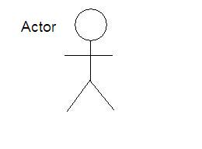**Fig. 1 Actor and Use case**

**USE CASE**

An actor is representing a user or another system that will interact with the system you are modelling.

A use case is an external view of the system that represents some action the user might perform in order to complete a task.

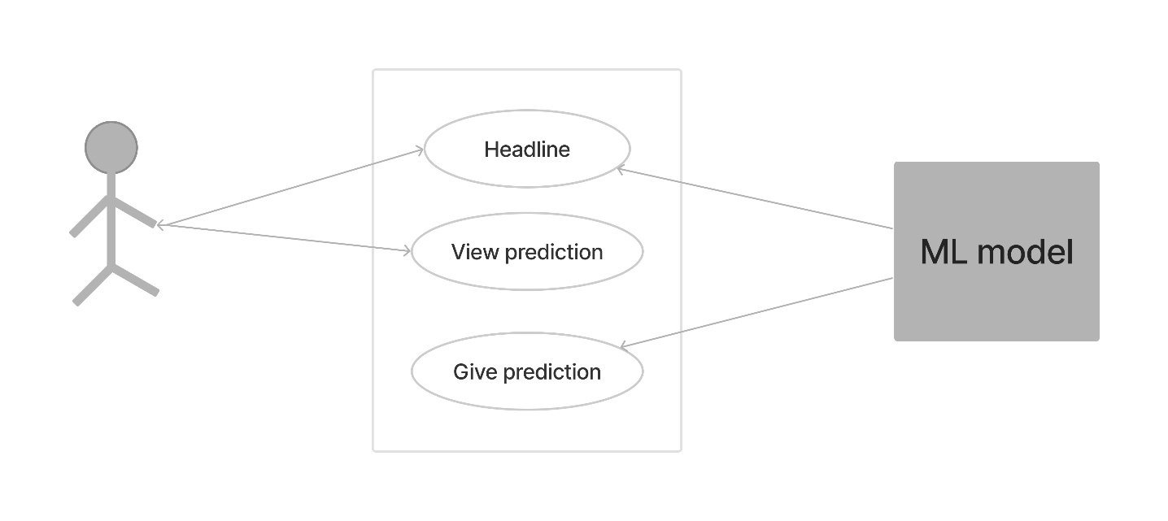

**Fig. 2 Interaction between user and website**

In The above diagram there is one actor or user who uses the system. This user is as follows:

1. Admin-The admin can login and logout of the system. Other than that, the admin of the system manages all the modules such as add an record, delete an record, update an record or print records.

**3.3 DATA FLOW DIAGRAM** **(DFD)**

A data flow diagram (DFD) is a graphical representation of the "flow" of data through an information system, modelling its process aspects. Often, they are a preliminary step used to create an overview of the system which can later be elaborated. DFDs can also be used for the visualization of data processing (structured design).

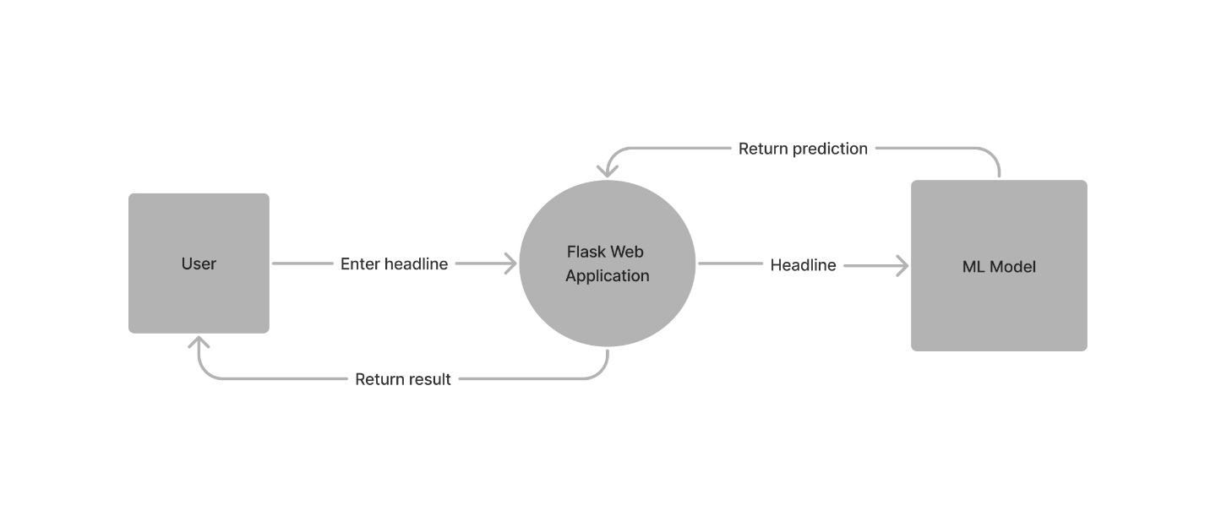

**Fig. 3 DFD level 0**

A DFD shows what kinds of information will be input to and output from the system, where the data will come from and go to, and where the data will be stored. It does not show information about the timing of processes, or information about whether processes will operate in sequence or in parallel (which is shown on a flowchart).

**Chapter 4**

**IMPLEMENTATION AND CODING**

**4.1 OPERATING SYSTEM**

**Platform Independent:** Since the project is a website, the application is platform independent. So, the client systems may have Windows, Linux, Mac or any other operating system, but they can run the application easily without any dependencies of OS.

**4.2 Languages used**

Python is a high-level, interpreted, and general-purpose programming language that is widely used for web development, data analysis, artificial intelligence, and scientific computing. It was first released in 1991 by Guido van Rossum and has since become one of the most popular programming languages in the world. One of the main advantages of Python is its readability and ease of use. The language has a simple and straightforward syntax that makes it easy to learn and use. Python also has a large and active community of developers who have created a vast collection of libraries and frameworks that can be used to perform a wide range of tasks.

Tailwind CSS is a utility-first CSS framework that provides a wide range of pre-built classes to quickly style web elements. It offers a highly customizable and efficient approach to styling, allowing developers to create responsive and modern user interfaces with ease. With its utility-based approach, Tailwind CSS simplifies the development process and promotes consistent design patterns.

Bootstrap is a popular front-end framework that provides a collection of ready-to-use HTML, CSS, and JavaScript components. It allows developers to quickly build responsive and mobile-first websites with its grid system, responsive utilities, and extensive component library. Bootstrap's robust features and easy integration makes it a go to choice for building visually appealing and functional web applications.

Flask is a lightweight and flexible web framework written in Python. It simplifies the process of building web applications by providing essential tools and libraries for handling routing, request handling, and template rendering. With its simplicity and scalability, Flask is widely used for developing both small-scale and complex web projects.

**4.3 S/W Tools**

**VS Code**

Visual Studio Code (VS Code) is a source code editor developed by Microsoft for Windows, Linux, and macOS. It is a free and open-source tool that is commonly used by developers to write and debug code. VS Code is built on top of the Electron framework, and it supports a wide range of programming languages including Python, C++, C#, Java, and JavaScript. It also has a built-in terminal, integrated Git control, and support for debugging and profiling. It also has a wide range of extensions that can be installed to add functionality such as linting, code completion, and debugging.

**4.4 CODING**

**4.4.1 Index page**

<!DOCTYPE html>

<html lang="en">

<head>

<meta charset="utf-8" />

<meta name="viewport" content="width=device-width, initial-scale=1" />

<title>NewsGuardian</title>

<link

href="https://cdn.jsdelivr.net/npm/bootstrap@5.3.0-alpha3/dist/css/bootstrap.min.css"

rel="stylesheet"

integrity="sha384-KK94CHFLLe+nY2dmCWGMq91rCGa5gtU4mk92HdvYe+M/SXH301p5ILy+dN9+nJOZ"

crossorigin="anonymous"

/>

<link

href="https://unpkg.com/tailwindcss@^2/dist/tailwind.min.css"

rel="stylesheet"

/>

<script async src="https://cdn.tailwindcss.com"></script>

</head>

<body>

<header class="text-gray-600 body-font -my-8">

<div

class="container mx-auto flex flex-wrap p-5 flex-col md:flex-row items-center"

>

<a

class="flex title-font font-medium items-center text-gray-900 mb-4 md:mb-0"

>

<svg

xmlns="http://www.w3.org/2000/svg"

fill="none"

stroke="currentColor"

stroke-linecap="round"

stroke-linejoin="round"

stroke-width="2"

class="w-10 h-10 text-white p-2 bg-purple-500 rounded-full"

viewBox="0 0 24 24"

>

<path

d="M12 2L2 7l10 5 10-5-10-5zM2 17l10 5 10-5M2 12l10 5 10-5"

></path>

</svg>

<span class="ml-3 text-xl">NewsGuardian</span>

</a>

<nav

class="md:ml-auto flex flex-wrap items-center text-base justify-center"

>

<a href="/" class="mr-5 hover:text-gray-900">Home</a>

<a href="/prediction" class="mr-5 hover:text-gray-900">Prediction</a>

<a href="/contact" class="mr-5 hover:text-gray-900">Contact Us</a>

</nav>

</div>

</header>

<hr />

<section class="text-gray-600 body-font -my-8">

<div

class="container mx-auto flex px-5 py-24 md:flex-row flex-col items-center"

>

<div

class="lg:flex-grow md:w-1/2 lg:pr-24 md:pr-16 flex flex-col md:items-start md:text-left mb-16 md:mb-0 items-center text-center"

>

<h1

class="title-font sm:text-4xl text-3xl mb-4 font-medium text-gray-900"

>

NewsGuardian

<br class="hidden lg:inline-block" />

</h1>

<p class="mb-8 leading-relaxed">

NewsGuardian is a cutting-edge fake news detection website designed

to empower individuals with accurate information in an era riddled

with misinformation. With advanced algorithms, a user-friendly

interface, and a commitment to truth, NewsGuardian stands as a

reliable ally in navigating the complex landscape of news and

ensuring the integrity of information.

</p>

<div class="flex justify-center">

<a href="/prediction"

><button

class="inline-flex text-white bg-purple-500 border-0 py-2 px-6 focus:outline-none hover:bg-purple-600 rounded text-lg"

>

Prediction

</button></a

>

</div>

</div>

<div class="lg:max-w-lg lg:w-full md:w-1/2 w-5/6">

<img

class="object-cover object-center rounded"

alt="hero"

src="/static/image.svg"

/>

</div>

</div>

</section>

<section class="text-gray-600 body-font -my-8">

<div class="container px-5 py-24 mx-auto">

<h1

class="text-3xl font-medium title-font text-gray-900 mb-12 text-center"

>

Testimonials

</h1>

<div class="flex flex-wrap -m-4">

<div class="p-4 md:w-1/2 w-full">

<div class="h-full bg-gray-100 p-8 rounded">

<svg

xmlns="http://www.w3.org/2000/svg"

fill="currentColor"

class="block w-5 h-5 text-gray-400 mb-4"

viewBox="0 0 975.036 975.036"

>

<path

d="M925.036 57.197h-304c-27.6 0-50 22.4-50 50v304c0 27.601 22.4 50 50 50h145.5c-1.9 79.601-20.4 143.3-55.4 191.2-27.6 37.8-69.399 69.1-125.3 93.8-25.7 11.3-36.8 41.7-24.8 67.101l36 76c11.6 24.399 40.3 35.1 65.1 24.399 66.2-28.6 122.101-64.8 167.7-108.8 55.601-53.7 93.7-114.3 114.3-181.9 20.601-67.6 30.9-159.8 30.9-276.8v-239c0-27.599-22.401-50-50-50zM106.036 913.497c65.4-28.5 121-64.699 166.9-108.6 56.1-53.7 94.4-114.1 115-181.2 20.6-67.1 30.899-159.6 30.899-277.5v-239c0-27.6-22.399-50-50-50h-304c-27.6 0-50 22.4-50 50v304c0 27.601 22.4 50 50 50h145.5c-1.9 79.601-20.4 143.3-55.4 191.2-27.6 37.8-69.4 69.1-125.3 93.8-25.7 11.3-36.8 41.7-24.8 67.101l35.9 75.8c11.601 24.399 40.501 35.2 65.301 24.399z"

></path>

</svg>

<p class="leading-relaxed mb-6">

I got recommended this website by my friend. This platform has

become my go-to tool for unraveling the truth. With its

intuitive interface and accurate algorithms, it's like having a

personal guide to navigate the treacherous jungle of fake news.

</p>

<a class="inline-flex items-center">

<img

alt="testimonial"

src="/static/piyush.jpg"

class="w-12 h-12 rounded-full flex-shrink-0 object-cover object-top"

/>

<span class="flex-grow flex flex-col pl-4">

<span class="title-font font-medium text-gray-900"

>Piyush Gautam</span

>

<span class="text-gray-500 text-sm">Researcher</span>

</span>

</a>

</div>

</div>

<div class="p-4 md:w-1/2 w-full">

<div class="h-full bg-gray-100 p-8 rounded">

<svg

xmlns="http://www.w3.org/2000/svg"

fill="currentColor"

class="block w-5 h-5 text-gray-400 mb-4"

viewBox="0 0 975.036 975.036"

>

<path

d="M925.036 57.197h-304c-27.6 0-50 22.4-50 50v304c0 27.601 22.4 50 50 50h145.5c-1.9 79.601-20.4 143.3-55.4 191.2-27.6 37.8-69.399 69.1-125.3 93.8-25.7 11.3-36.8 41.7-24.8 67.101l36 76c11.6 24.399 40.3 35.1 65.1 24.399 66.2-28.6 122.101-64.8 167.7-108.8 55.601-53.7 93.7-114.3 114.3-181.9 20.601-67.6 30.9-159.8 30.9-276.8v-239c0-27.599-22.401-50-50-50zM106.036 913.497c65.4-28.5 121-64.699 166.9-108.6 56.1-53.7 94.4-114.1 115-181.2 20.6-67.1 30.899-159.6 30.899-277.5v-239c0-27.6-22.399-50-50-50h-304c-27.6 0-50 22.4-50 50v304c0 27.601 22.4 50 50 50h145.5c-1.9 79.601-20.4 143.3-55.4 191.2-27.6 37.8-69.4 69.1-125.3 93.8-25.7 11.3-36.8 41.7-24.8 67.101l35.9 75.8c11.601 24.399 40.501 35.2 65.301 24.399z"

></path>

</svg>

<p class="leading-relaxed mb-6">

The interface is sleek, intuitive, and user-friendly, making it

accessible to individuals of all technological backgrounds.

<br /><br />

</p>

<a class="inline-flex items-center">

<img

alt="testimonial"

src="/static/naman1.jpg"

class="w-12 h-12 rounded-full flex-shrink-0 object-cover object-top"

/>

<span class="flex-grow flex flex-col pl-4">

<span class="title-font font-medium text-gray-900"

>Naman Parashar</span

>

<span class="text-gray-500 text-sm"

>WEB DEVELOPER, ANTLER</span

>

</span>

</a>

</div>

</div>

</div>

</div>

</section>

<section class="text-gray-600 body-font -my-8">

<div class="container px-5 py-24 mx-auto">

<h1

class="sm:text-3xl text-2xl font-medium title-font text-center text-gray-900 mb-20"

>

Features of NewsGuardian

</h1>

<div

class="flex flex-wrap sm:-m-4 -mx-4 -mb-10 -mt-4 md:space-y-0 space-y-6"

>

<div class="p-4 md:w-1/3 flex">

<div

class="w-12 h-12 inline-flex items-center justify-center rounded-full text-purple-500 mb-4 flex-shrink-0"

>

<svg

version="1.0"

xmlns="http://www.w3.org/2000/svg"

width="100.000000pt"

height="100.000000pt"

viewBox="0 0 100.000000 100.000000"

preserveAspectRatio="xMidYMid meet"

>

<g

transform="translate(0.000000,100.000000) scale(0.100000,-0.100000)"

fill="#000000"

stroke="none"

>

<path

d="M423 992 c-35 -11 -63 -40 -63 -66 0 -53 64 -79 174 -70 77 7 142 -6

174 -34 l21 -17 -25 -37 c-29 -45 -45 -47 -129 -18 -151 52 -294 1 -346 -124

-21 -52 -23 -54 -50 -44 -38 13 -100 -16 -113 -53 -22 -64 25 -115 103 -112

34 1 51 -4 73 -22 24 -20 102 -45 143 -45 26 0 26 -20 1 -51 -50 -59 -29 -94

68 -114 81 -17 108 -33 144 -85 30 -43 87 -80 124 -80 86 0 53 142 -48 205

l-43 28 43 33 c76 58 136 173 136 262 0 29 3 33 18 27 77 -32 157 -8 168 50

21 112 -39 200 -151 221 -23 4 -47 17 -58 31 -68 87 -257 146 -364 115z m224

-66 c34 -16 74 -41 90 -58 l28 -29 -50 28 c-46 26 -59 28 -160 29 -124 1 -158

8 -153 32 8 41 151 40 245 -2z m226 -130 c57 -24 79 -58 81 -123 1 -54 -1 -58

-27 -67 -19 -7 -40 -6 -70 3 -82 24 -81 25 -88 -59 -9 -109 -49 -179 -142

-250 -15 -11 -13 -4 7 35 45 85 30 184 -36 240 -34 29 -46 31 -54 11 -3 -8 10

-28 31 -48 30 -27 38 -43 42 -80 7 -61 -11 -110 -53 -147 -42 -37 -45 -66 -6

-74 80 -18 172 -100 172 -154 0 -44 -58 -17 -104 47 -38 53 -97 86 -169 96

-26 4 -50 11 -53 16 -3 4 6 22 21 40 32 38 30 77 -5 95 -14 7 -52 18 -85 24

-43 8 -66 19 -86 40 -24 26 -29 27 -62 17 -30 -9 -40 -8 -61 6 -15 9 -26 25

-26 35 0 44 65 58 104 22 27 -25 46 -12 46 31 0 16 9 45 19 66 53 104 163 138

296 92 97 -34 142 -25 171 33 35 69 69 82 137 53z"

/>

<path

d="M884 706 c-10 -26 4 -48 28 -44 17 2 23 10 23 28 0 18 -6 26 -23 28

-13 2 -25 -3 -28 -12z"

/>

<path

d="M65 849 c-15 -23 15 -30 126 -27 93 2 114 6 114 18 0 12 -21 16 -117

18 -78 2 -119 -1 -123 -9z"

/>

<path

d="M35 770 c-14 -22 10 -30 91 -30 77 0 84 2 84 20 0 18 -7 20 -84 20

-47 0 -88 -4 -91 -10z"

/>

<path

d="M5 690 c-14 -22 13 -31 86 -28 58 2 74 6 74 18 0 12 -16 16 -77 18

-49 2 -79 -1 -83 -8z"

/>

</g>

</svg>

</div>

<div class="flex-grow pl-6">

<h2 class="text-gray-900 text-lg title-font font-medium mb-2">

Fast and Efficient

</h2>

<p class="leading-relaxed text-base">

The platform provides quick and efficient fake news detection,

allowing users to verify information in real-time and make

informed decisions promptly.

</p>

</div>

</div>

<div class="p-4 md:w-1/3 flex">

<div

class="w-12 h-12 inline-flex items-center justify-center rounded-full text-purple-500 mb-4 flex-shrink-0"

>

<svg

version="1.0"

xmlns="http://www.w3.org/2000/svg"

width="100.000000pt"

height="100.000000pt"

viewBox="0 0 100.000000 100.000000"

preserveAspectRatio="xMidYMid meet"

>

<g

transform="translate(0.000000,100.000000) scale(0.100000,-0.100000)"

fill="#000000"

stroke="none"

>

<path

d="M230 911 c-46 -15 -85 -39 -116 -73 -54 -57 -69 -95 -69 -178 0 -89

19 -132 89 -200 26 -25 46 -53 46 -65 0 -21 47 -75 66 -75 5 0 17 -14 26 -30

10 -17 31 -38 48 -48 16 -9 30 -21 30 -26 0 -15 52 -66 66 -66 7 0 15 -9 19

-20 8 -27 62 -70 87 -70 22 0 208 179 208 199 0 6 6 11 13 11 16 0 67 52 67

68 0 7 6 12 13 12 7 0 28 15 46 34 27 27 32 40 28 62 -3 20 4 44 25 81 145

257 -169 515 -396 326 l-29 -24 -26 24 c-14 14 -42 33 -61 42 -38 20 -142 29

-180 16z m146 -46 c19 -8 49 -24 65 -36 l30 -21 -60 -63 c-33 -34 -63 -74 -67

-90 -15 -60 50 -126 111 -111 14 4 57 36 96 73 l70 67 122 -122 121 -121 -24

-26 c-13 -14 -28 -25 -33 -25 -5 0 -40 30 -78 67 -54 52 -72 64 -81 55 -10

-10 3 -27 55 -80 37 -37 67 -72 67 -77 0 -5 -10 -19 -22 -32 l-21 -23 -73 71

c-67 64 -94 78 -94 46 0 -6 30 -42 67 -79 l67 -68 -29 -30 -29 -30 -26 25

c-14 14 -31 25 -37 25 -6 0 -20 16 -32 35 -11 19 -31 40 -43 46 -13 6 -32 25

-43 42 -11 17 -31 37 -43 43 -13 7 -32 25 -42 42 -38 61 -79 67 -137 17 l-41

-35 -37 41 c-83 92 -96 193 -39 286 53 86 170 126 260 88z m381 3 c60 -15 137

-87 152 -143 20 -72 9 -145 -29 -196 l-19 -24 -121 119 -120 119 -84 -81 c-46

-45 -92 -82 -101 -82 -26 0 -55 29 -55 55 0 14 32 53 93 112 133 130 176 149

284 121z m-429 -411 l22 -23 -40 -39 c-33 -32 -44 -37 -57 -29 -38 24 -39 42

-3 79 40 41 49 43 78 12z m82 -82 l24 -26 -42 -42 -42 -42 -27 28 -27 27 39

40 c21 22 42 40 45 40 4 0 17 -11 30 -25z m82 -82 c25 -23 23 -34 -17 -73 -37

-36 -55 -35 -79 3 -8 13 -3 24 24 52 38 40 46 42 72 18z m88 -88 l24 -26 -42

-42 -42 -42 -27 28 -27 27 39 40 c21 22 42 40 45 40 4 0 17 -11 30 -25z"

/>

</g>

</svg>

</div>

<div class="flex-grow pl-6">

<h2 class="text-gray-900 text-lg title-font font-medium mb-2">

User-Friendly Interface

</h2>

<p class="leading-relaxed text-base">

With an intuitive and user-friendly interface, the website is

accessible to individuals of all tech-savviness levels, making

it easy for anyone to navigate and utilize its features.

</p>

</div>

</div>

<div class="p-4 md:w-1/3 flex">

<div

class="w-12 h-12 inline-flex items-center justify-center rounded-full text-purple-500 mb-4 flex-shrink-0"

>

<svg

version="1.0"

xmlns="http://www.w3.org/2000/svg"

width="100.000000pt"

height="100.000000pt"

viewBox="0 0 100.000000 100.000000"

preserveAspectRatio="xMidYMid meet"

>

<g

transform="translate(0.000000,100.000000) scale(0.100000,-0.100000)"

fill="#000000"

stroke="none"

>

<path

d="M455 966 c-42 -18 -83 -69 -91 -112 -14 -75 37 -161 155 -263 116

-100 114 -99 164 -65 70 49 192 176 217 227 36 78 18 148 -54 201 -40 30 -130

29 -173 -2 l-33 -23 -31 22 c-38 27 -112 35 -154 15z m152 -70 l33 -36 34 38

c31 33 39 37 85 37 41 0 55 -5 80 -29 43 -41 50 -88 21 -143 -22 -42 -142

-164 -194 -198 -24 -16 -28 -16 -51 -1 -50 33 -167 151 -192 193 -20 34 -24

52 -20 80 17 101 135 135 204 59z"

/>

<path

d="M785 370 l-111 -110 -100 1 -99 1 75 18 c107 26 141 80 85 135 -24

25 -27 25 -195 25 -124 0 -179 -4 -203 -14 -18 -8 -79 -62 -137 -120 l-105

-106 102 -102 103 -103 43 43 43 42 209 0 209 0 148 148 c162 161 171 179 123

227 -45 46 -67 36 -190 -85z m165 55 c6 -8 9 -22 6 -33 -3 -10 -64 -75 -134

-145 l-129 -127 -208 0 -209 0 -38 -37 -38 -37 -78 77 -77 78 92 90 c51 49

104 94 118 99 15 6 97 10 184 10 133 0 161 -3 172 -16 25 -30 -2 -48 -102 -68

-52 -11 -96 -21 -98 -23 -3 -2 11 -19 29 -38 l34 -35 105 0 105 0 111 110 c62

61 119 110 127 110 9 0 21 -7 28 -15z"

/>

</g>

</svg>

</div>

<div class="flex-grow pl-6">

<h2 class="text-gray-900 text-lg title-font font-medium mb-2">

Reliable Results

</h2>

<p class="leading-relaxed text-base">

With its rigorous analysis and cross-referencing of multiple

sources, the website delivers reliable and trustworthy results,

helping users distinguish between genuine and misleading

information.

</p>

</div>

</div>

</div>

</div>

</section>

<footer class="text-gray-600 body-font">

<div class="bg-gray-100">

<div

class="container px-5 py-6 mx-auto flex items-center sm:flex-row flex-col"

>

<a

class="flex title-font font-medium items-center md:justify-start justify-center text-gray-900"

>

<svg

xmlns="http://www.w3.org/2000/svg"

fill="none"

stroke="currentColor"

stroke-linecap="round"

stroke-linejoin="round"

stroke-width="2"

class="w-10 h-10 text-white p-2 bg-purple-500 rounded-full"

viewBox="0 0 24 24"

>

<path

d="M12 2L2 7l10 5 10-5-10-5zM2 17l10 5 10-5M2 12l10 5 10-5"

></path>

</svg>

<span class="ml-3 text-xl">NewsGuardian</span>

</a>

</div>

</div>

</footer>

<script

src="https://cdn.jsdelivr.net/npm/bootstrap@5.3.0-alpha3/dist/js/bootstrap.bundle.min.js"

integrity="sha384-ENjdO4Dr2bkBIFxQpeoTz1HIcje39Wm4jDKdf19U8gI4ddQ3GYNS7NTKfAdVQSZe"

crossorigin="anonymous"

></script>

</body>

</html>



**Fig. 4 Home Page (1)**



**Fig. 5 Home Page (2)**

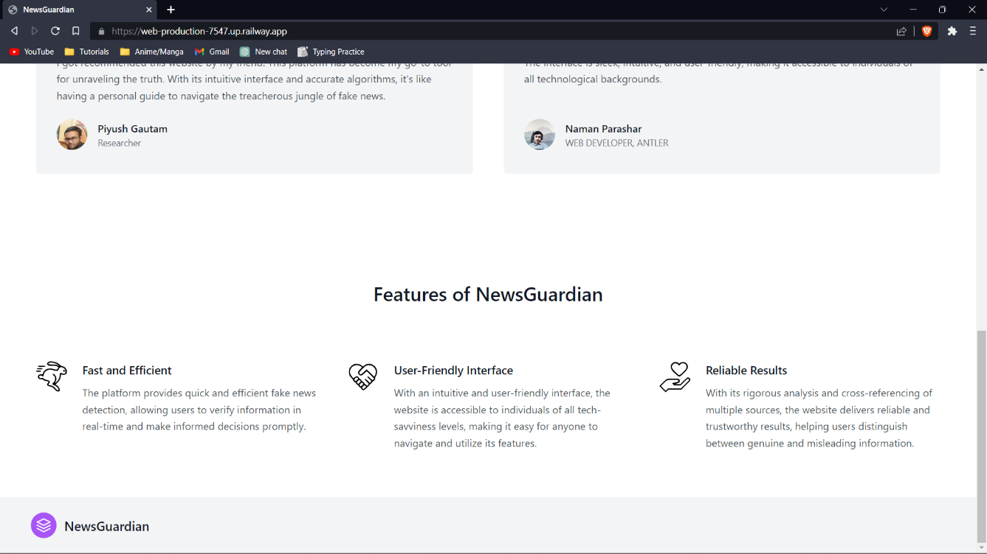

**Fig. 6 Home Page (3)**

**4.4.2 Prediction Page**

<!doctype html>

<html lang="en">

<head>

<meta charset="utf-8">

<meta name="viewport" content="width=device-width, initial-scale=1">

<title>NewsGuardian</title>

<link href="https://cdn.jsdelivr.net/npm/bootstrap@5.3.0-alpha3/dist/css/bootstrap.min.css" rel="stylesheet"

integrity="sha384-KK94CHFLLe+nY2dmCWGMq91rCGa5gtU4mk92HdvYe+M/SXH301p5ILy+dN9+nJOZ" crossorigin="anonymous">

<link href="https://unpkg.com/tailwindcss@^2/dist/tailwind.min.css" rel="stylesheet">

</head>

<body>

<header class="text-gray-600 body-font -my-8">

<div class="container mx-auto flex flex-wrap p-5 flex-col md:flex-row items-center">

<a class="flex title-font font-medium items-center text-gray-900 mb-4 md:mb-0">

<svg xmlns="http://www.w3.org/2000/svg" fill="none" stroke="currentColor" stroke-linecap="round"

stroke-linejoin="round" stroke-width="2" class="w-10 h-10 text-white p-2 bg-purple-500 rounded-full"

viewBox="0 0 24 24">

<path d="M12 2L2 7l10 5 10-5-10-5zM2 17l10 5 10-5M2 12l10 5 10-5"></path>

</svg>

<span class="ml-3 text-xl">NewsGuardian</span>

</a>

<nav class="md:ml-auto flex flex-wrap items-center text-base justify-center">

<a href="/" class="mr-5 hover:text-gray-900">Home</a>

<a href="/prediction" class="mr-5 hover:text-gray-900">Prediction</a>

<a href="/contact" class="mr-5 hover:text-gray-900">Contact Us</a>

</nav>

</div>

</header><hr>

<section class="text-gray-600 body-font -my-8">

<div class="container px-5 py-24 mx-auto">

<div class="flex flex-col text-center w-full mb-20">

<h2 class="text-xs text-purple-500 tracking-widest font-medium title-font mb-1">Machine learning project</h2>

<h1 class="sm:text-3xl text-2xl font-medium title-font mb-4 text-gray-900">NewsGuardian

</h1>

<p class="lg:w-2/3 mx-auto leading-relaxed text-base">NewsGuardian is a cutting-edge fake news detection website designed

to empower individuals with accurate information in an era riddled

with misinformation. With advanced algorithms, a user-friendly

interface, and a commitment to truth, NewsGuardian stands as a

reliable ally in navigating the complex landscape of news and

ensuring the integrity of information.</p>

<br><p><b>{{prediction_text}}</b></p>

</div>

<div class="center">

<form action="/prediction" method="POST">

<div class="mb-3">

<label for="exampleInputEmail1" class="form-label">Enter news headlines</label>

<input type="text" class="form-control" id="news" name="news" aria-describedby="emailHelp">

<div id="emailHelp" class="form-text">We'll never share your email with anyone else.</div>

</div>

</div>

<button type="submit" class="inline-flex text-white bg-purple-500 border-0 py-2 px-6 focus:outline-none hover:bg-purple-600 rounded text-lg">Submit</button>

</form>

</div>

</div>

</section>

<script src="https://cdn.jsdelivr.net/npm/bootstrap@5.3.0-alpha3/dist/js/bootstrap.bundle.min.js"

integrity="sha384-ENjdO4Dr2bkBIFxQpeoTz1HIcje39Wm4jDKdf19U8gI4ddQ3GYNS7NTKfAdVQSZe"

crossorigin="anonymous"></script>

</body>

</html>

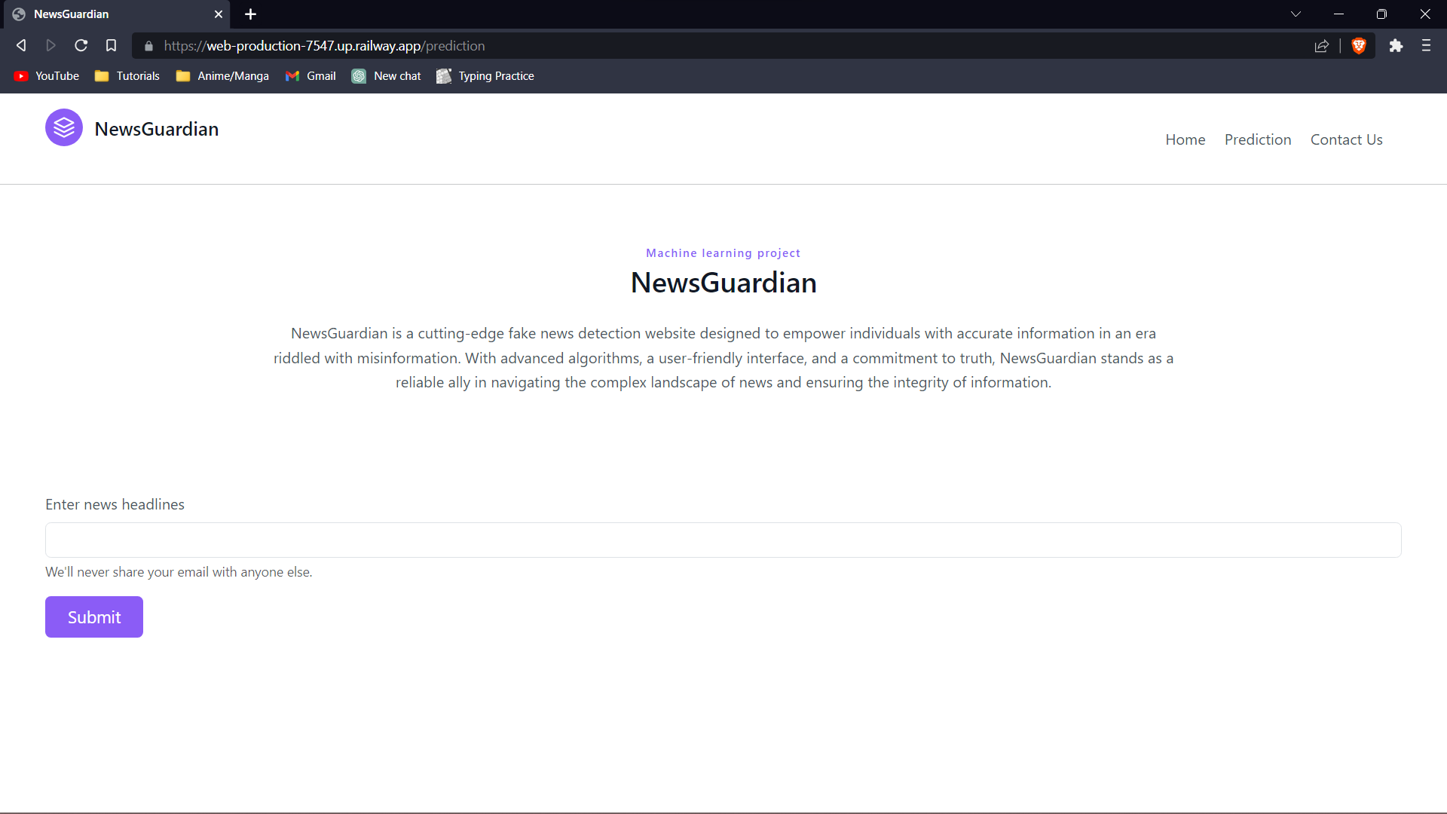

**Fig. 7 Prediction page**

**4.4.3 Contact Us Page**

<!doctype html>

<html lang="en">

<head>

<meta charset="utf-8">

<meta name="viewport" content="width=device-width, initial-scale=1">

<title>NewsGuardian</title>

<link href="https://cdn.jsdelivr.net/npm/bootstrap@5.3.0/dist/css/bootstrap.min.css" rel="stylesheet"

integrity="sha384-9ndCyUaIbzAi2FUVXJi0CjmCapSmO7SnpJef0486qhLnuZ2cdeRhO02iuK6FUUVM" crossorigin="anonymous">

<link href="https://unpkg.com/tailwindcss@^2/dist/tailwind.min.css" rel="stylesheet">

</head>

<body>

<header class="text-gray-600 body-font -my-8">

<div class="container mx-auto flex flex-wrap p-5 flex-col md:flex-row items-center">

<a class="flex title-font font-medium items-center text-gray-900 mb-4 md:mb-0">

<svg xmlns="http://www.w3.org/2000/svg" fill="none" stroke="currentColor" stroke-linecap="round"

stroke-linejoin="round" stroke-width="2" class="w-10 h-10 text-white p-2 bg-purple-500 rounded-full"

viewBox="0 0 24 24">

<path d="M12 2L2 7l10 5 10-5-10-5zM2 17l10 5 10-5M2 12l10 5 10-5"></path>

</svg>

<span class="ml-3 text-xl">Fake News Detection</span>

</a>

<nav class="md:ml-auto flex flex-wrap items-center text-base justify-center">

<a href="/" class="mr-5 hover:text-gray-900">Home</a>

<a href="/prediction" class="mr-5 hover:text-gray-900">Prediction</a>

<a href="/contact" class="mr-5 hover:text-gray-900">Contact Us</a>

</nav>

</div>

</header>

<hr>

<section class="text-gray-600 body-font">

<div class="container px-5 py-24 mx-auto">

<div class="flex flex-col text-center w-full mb-20">

<h1 class="text-2xl font-medium title-font mb-4 text-gray-900 tracking-widest">OUR TEAM</h1>

<p class="lg:w-2/3 mx-auto leading-relaxed text-base">Our passionate and committed team is at the forefront of the battle against fake news. With their unwavering dedication and expertise in information verification, they tirelessly strive to ensure the integrity and accuracy of the content on our platform. </p>

</div>

<div class="flex flex-wrap -m-4">

<div class="p-4 lg:w-1/2">

<div

class="h-full flex sm:flex-row flex-col items-center sm:justify-start justify-center text-center sm:text-left">

<img alt="team" class="flex-shrink-0 rounded-lg w-48 h-48 object-cover object-top sm:mb-0 mb-4"

src="/static/IMG20221210203016.jpg">

<div class="flex-grow sm:pl-8">

<h2 class="title-font font-medium text-lg text-gray-900">Pranav Chamoli</h2>

<h3 class="text-gray-500 mb-3">App Developer</h3>

<span class="inline-flex">

<a class="text-gray-500" href="https://www.linkedin.com/in/pranavchamoli08/" target="_blank">

<svg xmlns="http://www.w3.org/2000/svg"

viewBox="0 0 50 50"

width="24px"

height="24px">

<path

d="M 9 4 C 6.2504839 4 4 6.2504839 4 9 L 4 41 C 4 43.749516 6.2504839 46 9 46 L 41 46 C 43.749516 46 46 43.749516 46 41 L 46 9 C 46 6.2504839 43.749516 4 41 4 L 9 4 z M 9 6 L 41 6 C 42.668484 6 44 7.3315161 44 9 L 44 41 C 44 42.668484 42.668484 44 41 44 L 9 44 C 7.3315161 44 6 42.668484 6 41 L 6 9 C 6 7.3315161 7.3315161 6 9 6 z M 14 11.011719 C 12.904779 11.011719 11.919219 11.339079 11.189453 11.953125 C 10.459687 12.567171 10.011719 13.484511 10.011719 14.466797 C 10.011719 16.333977 11.631285 17.789609 13.691406 17.933594 A 0.98809878 0.98809878 0 0 0 13.695312 17.935547 A 0.98809878 0.98809878 0 0 0 14 17.988281 C 16.27301 17.988281 17.988281 16.396083 17.988281 14.466797 A 0.98809878 0.98809878 0 0 0 17.986328 14.414062 C 17.884577 12.513831 16.190443 11.011719 14 11.011719 z M 14 12.988281 C 15.392231 12.988281 15.94197 13.610038 16.001953 14.492188 C 15.989803 15.348434 15.460091 16.011719 14 16.011719 C 12.614594 16.011719 11.988281 15.302225 11.988281 14.466797 C 11.988281 14.049083 12.140703 13.734298 12.460938 13.464844 C 12.78117 13.19539 13.295221 12.988281 14 12.988281 z M 11 19 A 1.0001 1.0001 0 0 0 10 20 L 10 39 A 1.0001 1.0001 0 0 0 11 40 L 17 40 A 1.0001 1.0001 0 0 0 18 39 L 18 33.134766 L 18 20 A 1.0001 1.0001 0 0 0 17 19 L 11 19 z M 20 19 A 1.0001 1.0001 0 0 0 19 20 L 19 39 A 1.0001 1.0001 0 0 0 20 40 L 26 40 A 1.0001 1.0001 0 0 0 27 39 L 27 29 C 27 28.170333 27.226394 27.345035 27.625 26.804688 C 28.023606 26.264339 28.526466 25.940057 29.482422 25.957031 C 30.468166 25.973981 30.989999 26.311669 31.384766 26.841797 C 31.779532 27.371924 32 28.166667 32 29 L 32 39 A 1.0001 1.0001 0 0 0 33 40 L 39 40 A 1.0001 1.0001 0 0 0 40 39 L 40 28.261719 C 40 25.300181 39.122788 22.95433 37.619141 21.367188 C 36.115493 19.780044 34.024172 19 31.8125 19 C 29.710483 19 28.110853 19.704889 27 20.423828 L 27 20 A 1.0001 1.0001 0 0 0 26 19 L 20 19 z M 12 21 L 16 21 L 16 33.134766 L 16 38 L 12 38 L 12 21 z M 21 21 L 25 21 L 25 22.560547 A 1.0001 1.0001 0 0 0 26.798828 23.162109 C 26.798828 23.162109 28.369194 21 31.8125 21 C 33.565828 21 35.069366 21.582581 36.167969 22.742188 C 37.266572 23.901794 38 25.688257 38 28.261719 L 38 38 L 34 38 L 34 29 C 34 27.833333 33.720468 26.627107 32.990234 25.646484 C 32.260001 24.665862 31.031834 23.983076 29.517578 23.957031 C 27.995534 23.930001 26.747519 24.626988 26.015625 25.619141 C 25.283731 26.611293 25 27.829667 25 29 L 25 38 L 21 38 L 21 21 z" />

</svg>

</a>

<a class="text-gray-500" href="https://github.com/Z4nitsu" target="_blank">

<svg xmlns="http://www.w3.org/2000/svg" viewBox="0 0 50 50" width="24px" height="24px"><path d="M 25 2 C 12.311335 2 2 12.311335 2 25 C 2 37.688665 12.311335 48 25 48 C 37.688665 48 48 37.688665 48 25 C 48 12.311335 37.688665 2 25 2 z M 25 4 C 36.607335 4 46 13.392665 46 25 C 46 25.071371 45.994849 25.141688 45.994141 25.212891 C 45.354527 25.153853 44.615508 25.097776 43.675781 25.064453 C 42.347063 25.017336 40.672259 25.030987 38.773438 25.125 C 38.843852 24.634651 38.893205 24.137377 38.894531 23.626953 C 38.991361 21.754332 38.362521 20.002464 37.339844 18.455078 C 37.586913 17.601352 37.876747 16.515218 37.949219 15.283203 C 38.031819 13.878925 37.910599 12.321765 36.783203 11.269531 L 36.494141 11 L 36.099609 11 C 33.416539 11 31.580023 12.12321 30.457031 13.013672 C 28.835529 12.386022 27.01222 12 25 12 C 22.976367 12 21.135525 12.391416 19.447266 13.017578 C 18.324911 12.126691 16.486785 11 13.800781 11 L 13.408203 11 L 13.119141 11.267578 C 12.020956 12.287321 11.919778 13.801759 11.988281 15.199219 C 12.048691 16.431506 12.321732 17.552142 12.564453 18.447266 C 11.524489 20.02486 10.900391 21.822018 10.900391 23.599609 C 10.900391 24.111237 10.947969 24.610071 11.017578 25.101562 C 9.2118173 25.017808 7.6020996 25.001668 6.3242188 25.046875 C 5.3845143 25.080118 4.6454422 25.135713 4.0058594 25.195312 C 4.0052628 25.129972 4 25.065482 4 25 C 4 13.392665 13.392665 4 25 4 z M 14.396484 13.130859 C 16.414067 13.322043 17.931995 14.222972 18.634766 14.847656 L 19.103516 15.261719 L 19.681641 15.025391 C 21.263092 14.374205 23.026984 14 25 14 C 26.973016 14 28.737393 14.376076 30.199219 15.015625 L 30.785156 15.273438 L 31.263672 14.847656 C 31.966683 14.222758 33.487184 13.321554 35.505859 13.130859 C 35.774256 13.575841 36.007486 14.208668 35.951172 15.166016 C 35.883772 16.311737 35.577304 17.559658 35.345703 18.300781 L 35.195312 18.783203 L 35.494141 19.191406 C 36.483616 20.540691 36.988121 22.000937 36.902344 23.544922 L 36.900391 23.572266 L 36.900391 23.599609 C 36.900391 26.095064 36.00178 28.092339 34.087891 29.572266 C 32.174048 31.052199 29.152663 32 24.900391 32 C 20.648118 32 17.624827 31.052192 15.710938 29.572266 C 13.797047 28.092339 12.900391 26.095064 12.900391 23.599609 C 12.900391 22.134903 13.429308 20.523599 14.40625 19.191406 L 14.699219 18.792969 L 14.558594 18.318359 C 14.326866 17.530484 14.042825 16.254103 13.986328 15.101562 C 13.939338 14.14294 14.166221 13.537027 14.396484 13.130859 z M 8.8847656 26.021484 C 9.5914575 26.03051 10.40146 26.068656 11.212891 26.109375 C 11.290419 26.421172 11.378822 26.727898 11.486328 27.027344 C 8.178972 27.097092 5.7047309 27.429674 4.1796875 27.714844 C 4.1152068 27.214494 4.0638483 26.710021 4.0351562 26.199219 C 5.1622058 26.092262 6.7509972 25.994233 8.8847656 26.021484 z M 41.115234 26.037109 C 43.247527 26.010033 44.835728 26.108156 45.962891 26.214844 C 45.934234 26.718328 45.883749 27.215664 45.820312 27.708984 C 44.24077 27.41921 41.699674 27.086688 38.306641 27.033203 C 38.411945 26.739677 38.499627 26.438219 38.576172 26.132812 C 39.471291 26.084833 40.344564 26.046896 41.115234 26.037109 z M 11.912109 28.019531 C 12.508849 29.215327 13.361516 30.283019 14.488281 31.154297 C 16.028825 32.345531 18.031623 33.177838 20.476562 33.623047 C 20.156699 33.951698 19.86578 34.312595 19.607422 34.693359 L 19.546875 34.640625 C 19.552375 34.634325 19.04975 34.885878 18.298828 34.953125 C 17.547906 35.020374 16.621615 35 15.800781 35 C 14.575781 35 14.03621 34.42121 13.173828 33.367188 C 12.696283 32.72356 12.114101 32.202331 11.548828 31.806641 C 10.970021 31.401475 10.476259 31.115509 9.8652344 31.013672 L 9.7832031 31 L 9.6992188 31 C 9.2325521 31 8.7809835 31.03379 8.359375 31.515625 C 8.1485707 31.756544 8.003277 32.202561 8.0976562 32.580078 C 8.1920352 32.957595 8.4308563 33.189581 8.6445312 33.332031 C 10.011254 34.24318 10.252795 36.046511 11.109375 37.650391 C 11.909298 39.244315 13.635662 40 15.400391 40 L 18 40 L 18 44.802734 C 10.967811 42.320535 5.6646795 36.204613 4.3320312 28.703125 C 5.8629338 28.414776 8.4265387 28.068108 11.912109 28.019531 z M 37.882812 28.027344 C 41.445538 28.05784 44.08105 28.404061 45.669922 28.697266 C 44.339047 36.201504 39.034072 42.31987 32 44.802734 L 32 39.599609 C 32 38.015041 31.479642 36.267712 30.574219 34.810547 C 30.299322 34.368135 29.975945 33.949736 29.615234 33.574219 C 31.930453 33.11684 33.832364 32.298821 35.3125 31.154297 C 36.436824 30.284907 37.287588 29.220424 37.882812 28.027344 z M 23.699219 34.099609 L 26.5 34.099609 C 27.312821 34.099609 28.180423 34.7474 28.875 35.865234 C 29.569577 36.983069 30 38.484177 30 39.599609 L 30 45.398438 C 28.397408 45.789234 26.72379 46 25 46 C 23.27621 46 21.602592 45.789234 20 45.398438 L 20 39.599609 C 20 38.508869 20.467828 37.011307 21.208984 35.888672 C 21.950141 34.766037 22.886398 34.099609 23.699219 34.099609 z M 12.308594 35.28125 C 13.174368 36.179258 14.222525 37 15.800781 37 C 16.579948 37 17.552484 37.028073 18.476562 36.945312 C 18.479848 36.945018 18.483042 36.943654 18.486328 36.943359 C 18.36458 37.293361 18.273744 37.645529 18.197266 38 L 15.400391 38 C 14.167057 38 13.29577 37.55443 12.894531 36.751953 L 12.886719 36.738281 L 12.880859 36.726562 C 12.716457 36.421191 12.500645 35.81059 12.308594 35.28125 z"/></svg>

</a>

</span>

</div>

</div>

</div>

<div class="p-4 lg:w-1/2">

<div

class="h-full flex sm:flex-row flex-col items-center sm:justify-start justify-center text-center sm:text-left">

<img alt="team" class="flex-shrink-0 rounded-lg w-48 h-48 object-cover object-top sm:mb-0 mb-4"

src="/static/jitesh.jpg">

<div class="flex-grow sm:pl-8">

<h2 class="title-font font-medium text-lg text-gray-900">Jitesh Gautam</h2>

<h3 class="text-gray-500 mb-3">Data Analyst</h3>

<span class="inline-flex">

<a class="text-gray-500" href="https://www.linkedin.com/in/jitesh-gautam-89369621a/" target="_blank">

<svg xmlns="http://www.w3.org/2000/svg"

viewBox="0 0 50 50"

width="24px"

height="24px">

<path

d="M 9 4 C 6.2504839 4 4 6.2504839 4 9 L 4 41 C 4 43.749516 6.2504839 46 9 46 L 41 46 C 43.749516 46 46 43.749516 46 41 L 46 9 C 46 6.2504839 43.749516 4 41 4 L 9 4 z M 9 6 L 41 6 C 42.668484 6 44 7.3315161 44 9 L 44 41 C 44 42.668484 42.668484 44 41 44 L 9 44 C 7.3315161 44 6 42.668484 6 41 L 6 9 C 6 7.3315161 7.3315161 6 9 6 z M 14 11.011719 C 12.904779 11.011719 11.919219 11.339079 11.189453 11.953125 C 10.459687 12.567171 10.011719 13.484511 10.011719 14.466797 C 10.011719 16.333977 11.631285 17.789609 13.691406 17.933594 A 0.98809878 0.98809878 0 0 0 13.695312 17.935547 A 0.98809878 0.98809878 0 0 0 14 17.988281 C 16.27301 17.988281 17.988281 16.396083 17.988281 14.466797 A 0.98809878 0.98809878 0 0 0 17.986328 14.414062 C 17.884577 12.513831 16.190443 11.011719 14 11.011719 z M 14 12.988281 C 15.392231 12.988281 15.94197 13.610038 16.001953 14.492188 C 15.989803 15.348434 15.460091 16.011719 14 16.011719 C 12.614594 16.011719 11.988281 15.302225 11.988281 14.466797 C 11.988281 14.049083 12.140703 13.734298 12.460938 13.464844 C 12.78117 13.19539 13.295221 12.988281 14 12.988281 z M 11 19 A 1.0001 1.0001 0 0 0 10 20 L 10 39 A 1.0001 1.0001 0 0 0 11 40 L 17 40 A 1.0001 1.0001 0 0 0 18 39 L 18 33.134766 L 18 20 A 1.0001 1.0001 0 0 0 17 19 L 11 19 z M 20 19 A 1.0001 1.0001 0 0 0 19 20 L 19 39 A 1.0001 1.0001 0 0 0 20 40 L 26 40 A 1.0001 1.0001 0 0 0 27 39 L 27 29 C 27 28.170333 27.226394 27.345035 27.625 26.804688 C 28.023606 26.264339 28.526466 25.940057 29.482422 25.957031 C 30.468166 25.973981 30.989999 26.311669 31.384766 26.841797 C 31.779532 27.371924 32 28.166667 32 29 L 32 39 A 1.0001 1.0001 0 0 0 33 40 L 39 40 A 1.0001 1.0001 0 0 0 40 39 L 40 28.261719 C 40 25.300181 39.122788 22.95433 37.619141 21.367188 C 36.115493 19.780044 34.024172 19 31.8125 19 C 29.710483 19 28.110853 19.704889 27 20.423828 L 27 20 A 1.0001 1.0001 0 0 0 26 19 L 20 19 z M 12 21 L 16 21 L 16 33.134766 L 16 38 L 12 38 L 12 21 z M 21 21 L 25 21 L 25 22.560547 A 1.0001 1.0001 0 0 0 26.798828 23.162109 C 26.798828 23.162109 28.369194 21 31.8125 21 C 33.565828 21 35.069366 21.582581 36.167969 22.742188 C 37.266572 23.901794 38 25.688257 38 28.261719 L 38 38 L 34 38 L 34 29 C 34 27.833333 33.720468 26.627107 32.990234 25.646484 C 32.260001 24.665862 31.031834 23.983076 29.517578 23.957031 C 27.995534 23.930001 26.747519 24.626988 26.015625 25.619141 C 25.283731 26.611293 25 27.829667 25 29 L 25 38 L 21 38 L 21 21 z" />

</svg>

</span>

</div>

</div>

</div>

</section>

<script src="https://cdn.jsdelivr.net/npm/bootstrap@5.3.0/dist/js/bootstrap.bundle.min.js"

integrity="sha384-geWF76RCwLtnZ8qwWowPQNguL3RmwHVBC9FhGdlKrxdiJJigb/j/68SIy3Te4Bkz"

crossorigin="anonymous"></script>

</body>

</html>

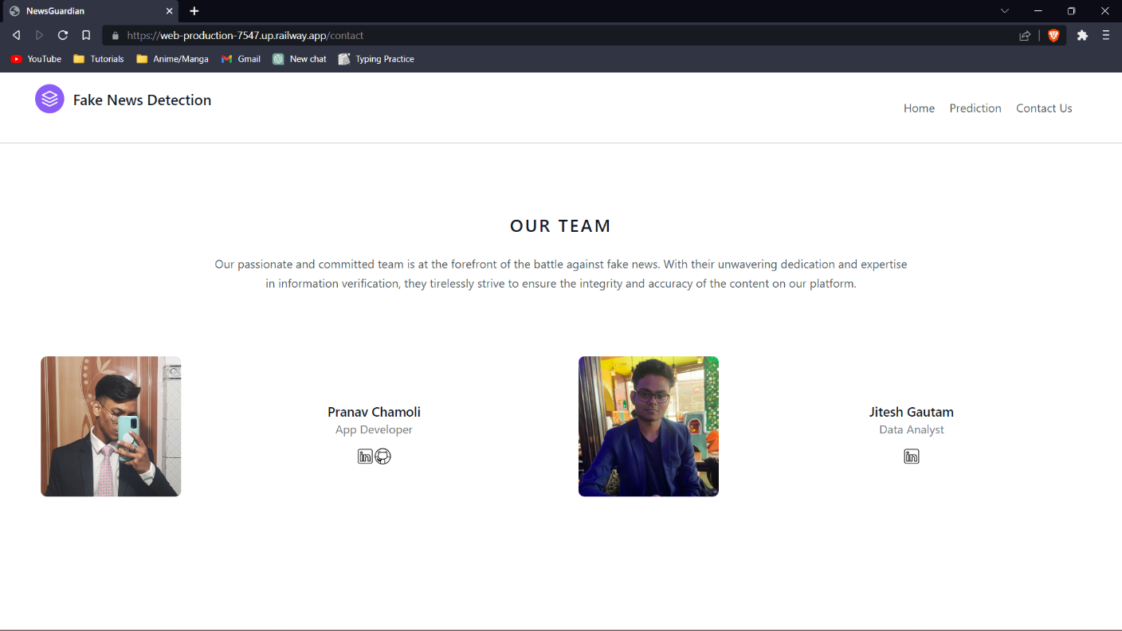

**Fig. 8 Contact Us Page**

**4.4.4 Flask file**

from flask import Flask, request, render_template

from markupsafe import Markup

import pickle

vector = pickle.load(open("vectorizer.pkl", "rb"))

model = pickle.load(open("finalized_model.pkl", "rb"))

app = Flask(__name__)

@app.route("/")

def home():

return render_template("index.html")

@app.route("/prediction", methods=['GET', 'POST'])

def prediction():

if request.method == "POST":

news = str(request.form['news'])

print(news)

predict = model.predict(vector.transform([news]))[0]

print(predict)

return render_template("prediction.html", prediction_text="News headline is -> {}".format(predict))

else:

return render_template("prediction.html")

@app.route("/contact")

def contact():

return render_template("contact.html")

if __name__ == '__main__':

app.run()

**4.4.5 jupyter file**

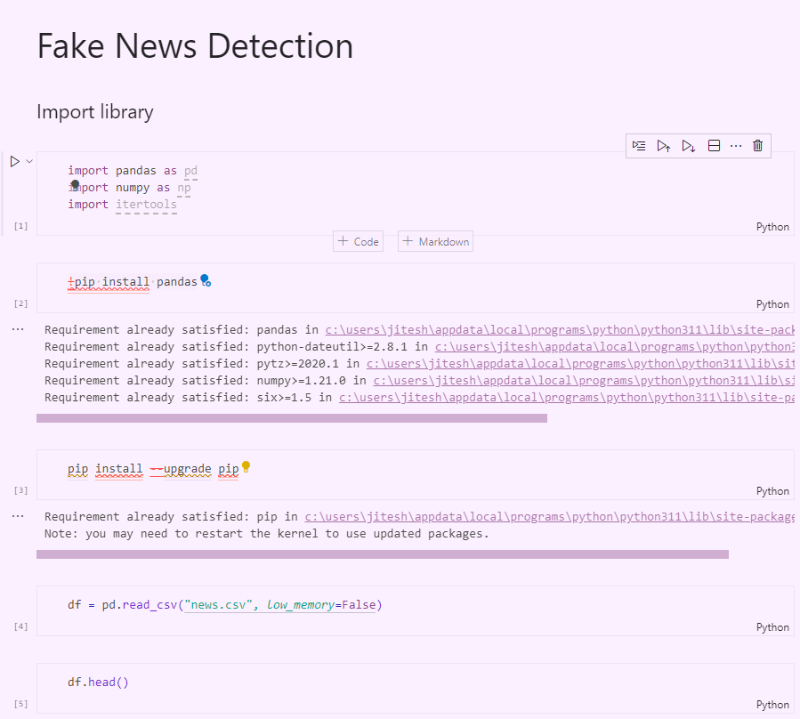

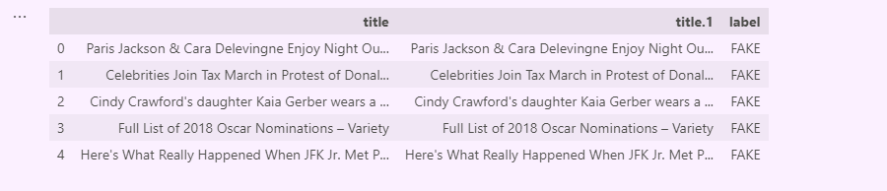

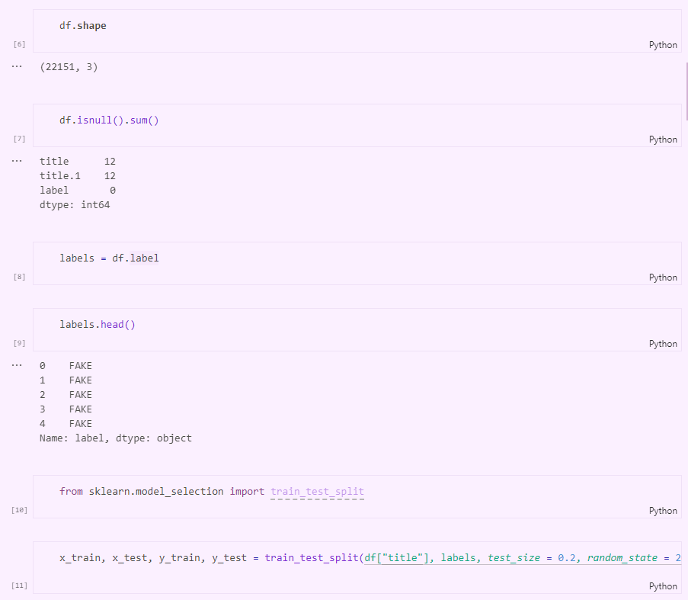

**Chapter 5**

**TESTING & TEST RESULTS**

**5.1 SOFTWARE TESTING**

Software testing is a critical element of software quality assurance and represents the ultimate review of specification design and coding. Testing is an exposure of a system to trial input to see whether software meets correct output. Testing cannot be determined whether software meets user’s needs, only whether it appears to confirm to requirements. Testing can show that a system is free of errors, only that it contains error. Testing finds errors, it does not correct errors. Software success is a quality product, on time and within cost. Through testing can reveal critical mistakes. Testing should therefore,

1. Validate Performance
2. Detects Errors
3. Identify Inconsistencies

**5.2 Test Objective**

* There is strong evidence that effective requirement management leads to overall project cost savings. The three primary reasons for this are,
* Requirement errors typically cost well over 10 times more to repair than other errors.
* Requirement errors typically comprise over 40% of all errors in a software project.
* Small reduction in the number of requirement errors pays big dividend in avoided rework costs and schedule delays.
* Systems are not designed as entire systems nor are they tested as single systems the analyst must perform both unit and system testing. For this different level testing are use:

**5.2.1 Unit Testing**

In unit testing Module is tested separately and the programmer simultaneously along with the coding of the module performs it.

In unit testing the analyst tests the programs making up a system. For this reason, unit testing is sometime called program testing. Unit testing gives stress on modules independently of one another, to find errors. This helps the tester in detecting errors in coding and logic that are contained within that module alone. The errors resulting from the interaction between modules are initially avoided.

Unit testing can be performed from the bottom up, starting with smallest and lowest-level modules and proceeding one at a time., for each module in Bottom-up testing a short program is used to execute the module and provides the needed data, so that the module is asked to perform the way it will when embed within the larger system.

**5.2.2 System Testing**

This is performed after the system is put together. The system is tested against the system requirement to check if all the requirements are met and if the system performs of specify by the requirements.

Testing is an important function to the success of the system. System testing makes a logical assumption that if all the parts of the system are correct, the goal will be successfully activated. Another reason for system testing is its utility as a user-oriented vehicle before implementation.

The function of testing is to detect the defects in the Software. The main goal testing is to uncover requirement, design, and coding errors in the programs. The types of testing are discussed below:

**5.2.3 MODEL TESTING**

**TEST CASES**

**Confusion Matrix:** The confusion matrix provides a detailed breakdown of the model's predictions. It shows the number of true positives, true negatives, false positives, and false negatives. The heatmap visualization helps us understand how well the model is classifying the news articles as "FAKE" or "REAL". We can observe the distribution of correct and incorrect predictions and identify any patterns or biases in the model's performance.

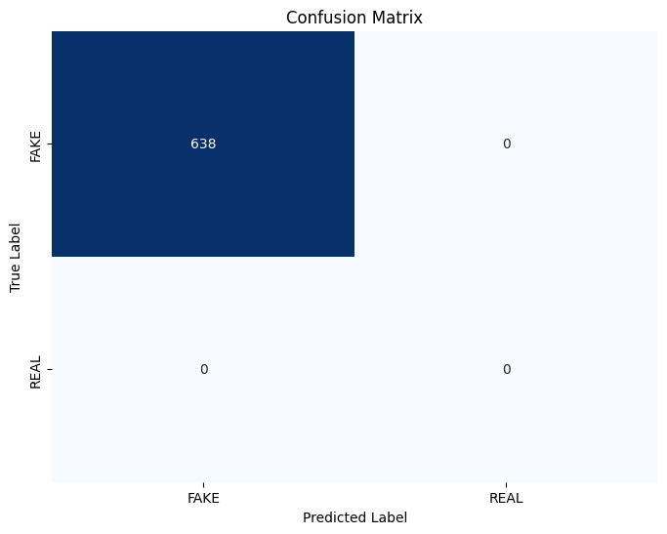

**Fig. 9 Confusion Matrix**

**Class Distribution:** The bar plot of the class distribution helps us understand the balance or imbalance between the classes in the dataset. It shows the count of samples for each class ("FAKE" and "REAL"). If there is a significant class imbalance, it can affect the model's performance and we might need to take steps to address it, such as using techniques like oversampling or under sampling.

**Fig. 10 Class Distribution**

**ROC Curve:** The ROC (Receiver Operating Characteristic) curve illustrates the performance of the model across various classification thresholds. It plots the true positive rate (sensitivity) against the false positive rate (1-specificity) at different threshold values. The area under the ROC curve (AUC) provides a measure of the model's ability to distinguish between the two classes. A higher AUC indicates better discrimination between "FAKE" and "REAL" news articles.

**Fig. 11 ROC Curve**

By analyzing these tests and graphs, we can assess the model's accuracy, understand its performance for each class, evaluate class distribution, and measure its ability to discriminate between the classes. These insights help us make informed decisions about the model and potentially identify areas for improvement or further analysis.

**Chapter 6**

**CONCLUSION**

**6.1 CONCLUSION**

In conclusion, the NewsGuardian project aims to address the critical issue of fake news by leveraging machine learning algorithms and a user-friendly website interface. By combining technologies like Flask, Tailwind CSS, and Bootstrap, the project offers a seamless user experience with responsive design and intuitive features. With its robust backend development, rigorous testing, and emphasis on performance optimization, NewsGuardian is poised to be an effective tool in combating the spread of fake news and promoting media literacy.

The system was tested and found to be fully functional and efficient. The user interface is interactive and easy to use. The system has been designed keeping in mind the scalability and security aspects.

**6.2 FUTURE SCOPE**

Every project whether large or small has some limitations no matter however diligently developed. In some cases, limitations are small while in other cases they may be broad also. The new system has got some limitations. Major areas where modifications can be done are as follows:

* Machine learning algorithm can be improved.
* The security is limited so some additional arrangement could be made to provide more security to the system.
* There is no provision of complain handling so further it can be added.

**BIBLIOGRAPHY**

* <https://openai.com/blog/chatgpt/>
* <https://www.geeksforgeeks.org/python-programming-language/?ref=shm>
* <https://docs.python.org/3/>
* <https://stackoverflow.com/>
* <https://www.wikipedia.org/>
* <https://code.visualstudio.com/docs>
* <https://www.tutorialspoint.com/python/python_gui_programming.htm>
* <https://tailwindcss.com/docs/installation>
* <https://getbootstrap.com/docs/5.3/getting-started/introduction/>
* <https://undraw.co/>
* <https://www.tutorialspoint.com/flask/index.html>